**-: Migration Project :-**

The company named “**THE GROCERY STORE**” initially has their store analysis report in Tableau. Now Client wants to move the report into Power BI, and for that they connect to our team. The management wants the exact same report and insights as they have in Tableau.

Follow the below instructions which help to see Tableau Dashboard freely on your system and further you can start building the report in Power BI

1. Double click on the below highlighted file to Install Tableau Reader provided to you, which is a free tool, and you can install it by just accepting terms and conditions.

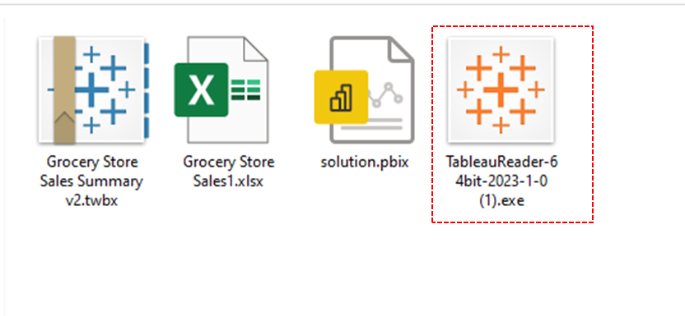

1. After Installation, Open the Tableau reader which looks like below.

1. Click on the File option and open the file:  
     
   Graphical user interface, application

   Description automatically generated
2. Select the provided .twbx file from your system  
     
   Graphical user interface, text, application

   Description automatically generated
3. It will open the Dashboard for you, where you can interact with the visuals and filter. Also, it will help to get the basic idea for creating the same dashboard in Power BI Desktop.

1. “THE GROCERY STORE” team also provided data in excel which you can import into the Power BI Desktop to build the report.